Name: _______________________ Class: __________ Date: _______
Instructions: Write answers in the right-hand column. Score: ___________ / 45 marks
Section A— Multiple choice (10marks)
 | The aircraft shown below has four forces acting on it.  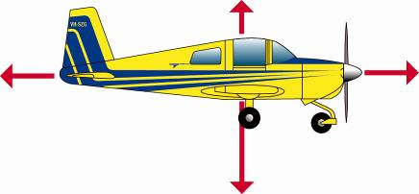  As a result of these forces, it will:  A Move to the right  B Move to the left  C Move up  D Move down | D | 1
 | Newton’s first law of motion can also be called the law of:  A Friction  B Gravity  C Magnetism  D Inertia | D | 1
 | A car moving in a straight line at constant speed:  A is accelerating.  B is decelerating.  C has no overall force acting on it.  D must be on a downhill slope. | c | 1
 | Trolleys are used to shift furniture because rolling surfaces produce:  A more friction than sliding surfaces.  B no friction.  C less friction than sliding surfaces.  D lots of heat which helps the furniture to move smoothly. | C | 1
 | A lubricant, such as oil:  A produces friction.  B reduces friction.  C increases friction.  D is a force caused by two surfaces moving over each other. | b | 1
 | It is more slippery walking on ice than walking on a footpath. This is because:  A there is more friction between the ice and your shoes.  B there is less friction between the ice and your shoes.  C your shoes get wet.  D you weigh less on ice than on the footpath. | B | 1
 | Weight is:  A the same as mass.  B a force due to gravity on an object.  C a period of time.  D the amount of matter in an object. | b | 1
 | Select the incorrect response about magnets.  A All magnets are permanent.  B All magnets have a north and a south pole.  C The north pole of one magnet is attracted to the south pole of another magnet.  D The north pole of one magnet will be repelled by the north pole of a second magnet. | A | 1
 | Select the response that is incorrect.  A A positively charged object is attracted to another positively charged object.  B A positively charged object is attracted to a negatively charged object.  C A negatively charged object can be discharged by losing electrons.  D A negatively charged object is attracted to a neutral object. | A | 1
 | A plastic rod was rubbed with a piece of cloth and is now positively charged. This means that it has:  A gained electrons from the cloth.  B lost electrons to the cloth.  C gained protons from the cloth.  D lost protons to the cloth. | B | 1
Section B— Short answer (25 marks)

- ` | The force that allows things to float is called buoyancy. Ship A and Ship B both have a buoyancy force acting upwards and a weight force acting downwards.  Ship A  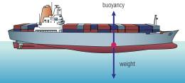  Ship B  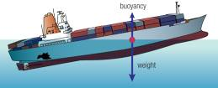  Describe what you think will happen to each ship, giving reasons for your answers. | The upwards buoyancy force of Ship A balances its weight force acting downwards. This means that it will continue to float on the water.  The weight force of Ship B is larger than the upwards force of buoyancy. These forces are not balanced, so Ship B will sink. | 4
 | This car is moving forward at a constant speed. Forces B and D acting on the car are equal in size.  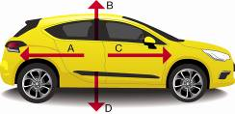  Identify what would need to happen to the size of forces A and C for this car to:  a speed up.  b slow down | a For the car to speed up, force C must be larger than force A.  b For the car to slow down, force A must be larger than force C. | 2
 | Explain what is meant by the term inertia. | Inertia can be described as the tendency of any object to resist changes in its motion. | 1
 | You are riding a scooter and hit a stone on a path. You fall forwards over the handlebars.  Explain what happened in terms of your inertia. | Before you hit the stone, your motion and the scooter’s motion were both in a forward direction. When the scooter hits the stone, the scooter stops but your body resists change in its motion and continues to travel in a forward direction. This means that you fall over the handlebars and onto the path ahead. | 2
 | State whether friction is beneficial or a nuisance in each situation below. Explain your answer.  a Your car engine gets hot as the car is driven.  b You apply the brakes on your bike when you see a child on the road ahead. | a In this case, friction is a nuisance. As parts of a car engine move against each other, the friction produces a lot of heat. Cars require a radiator to remove heat from the engine. The production of this heat makes cars very inefficient, which mean that they require much more fuel to run than they would need if there was no friction. In addition, friction causes wear and tear on parts, adding to the expensive of maintaining the car.  b This friction is beneficial. Without the grip provided by friction between the brake pads and the bike wheel, you would not be able to stop quickly. | 4
 | On the Moon, a stone and a feather dropped together will hit the ground at the same time. When this experiment is repeated on Earth, the stone hits the ground first.  Explain why this happens. | In both cases, the stone and the feather fall with the same acceleration due to gravity. However, because there is no atmosphere on the Moon, there is no air resistance or drag to slow the objects down.  Because the Earth has an atmosphere, objects that have a larger surface area catch more air as they fall. This drag force slows them down. A feather has a much larger surface area than a stone, so it is slowed by this air resistance and takes longer to fall the same distance. | 2
 | a Recall which three materials are attracted by a magnet.  b State in which part of a magnet the magnetic field is the strongest.  c State what happens when the following magnet ends are brought close to each other.  i A south pole and a north pole.  ii A south pole and another south pole.  iii A north pole and another north pole. | a Nickel, cobalt and iron are attracted by a magnet:  b A magnet is strongest at its poles.  c i Attract  ii Repel  iii Repel | 5
 | The diagram below shows some tiny magnetic particles inside iron bars.  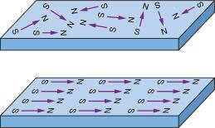  a Recall the name of these tiny particles.  b Identify which of these iron bars would act as a magnet and explain why this occurs. | a These tiny particles are called domains.  b Bar Y would act as a magnet because all of the domains within it are aligned in the same direction. | 2
 | Identify whether each atom shown in the diagram below is positively charged, negatively charged or neutral.  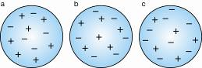 | a Positively charged  b Neutral  c Negatively charged | 3
 | Jen walks across a carpeted floor and then gets a small shock when she touches a metal door handle. Analyse what has happened in terms of static electricity. | As Jen walked across the carpeted floor, electrons rubbed off the carpet onto her body through her shoes. As a result, Jen had a slight negative charge. When she touched the metal door handle, these extra electrons flowed through Jen to the metal. Jen felt this as a static shock and she is no longer charged. | 2

Section C— Thinking scientifically (10 marks)

 | For an aircraft to successfully take off, the lift force provided by its wings must be greater than the aircraft’s weight force. The thrust provided by its engine must also be greater than any drag forces. To coast in the air, forces are balanced. A successful landing is the reverse process of the launch.  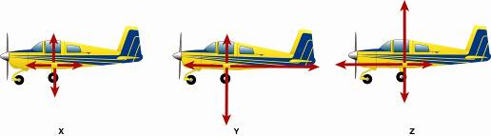  The order of diagrams that demonstrates the combination of force pairs required for an aircraft take-off, cruising at altitude, and a safe landing is:  A X, Y, Z  B Y, X, Z  C Z, Y, X  D Z, X, Y | D | 1
 | The less friction between the surface of a road and the tyres of a car, the greater distance the car will require to come to a stop. A wet road provides less friction than a dry road. Ice on the road provides even less friction than a wet road. Using this information, select the likely stopping distances (in metres) for a car travelling at 50 km/h from the table below:  Select  Wet road surface  (m)  Dry road surface  (m)  Icy road surface  (m)  A  40  30  35  B  30  40  70  C  25  35  60  D  50  25  80 | D | 1
 | The table below compares the gravity on other planets with that on Earth.  Planet  Gravity compared to Earth  Mercury  0.4  Venus  0.9  Earth  1.0  Mars  0.4  Jupiter  2.5  Saturn  1.1  Uranus  0.9  Neptune  1.1  Imagine that you weigh 450 N on Earth and that on another planet, you weigh 1125 N. According to the data shown in the table, the planet you must now be on is:  A Mercury  B Venus  C Jupiter  D Saturn | C | 1
 | The size of a force can be measured using a spring. The greater the weight force, the greater distance a spring will be extended when an object is suspended from it. If a 50 N weight stretches a particular spring by 6 cm, then a 125 N weight would be likely to stretch the same spring by:  A 6 cm  B 12 cm  C 15 cm  D 18 cm | C | 1
 | Use the following information to answer questions 5 and 6.  Omar and Sally set up an electromagnet by coiling a wire 25 times and connecting it to a power pack. They tested to see how many paper clips their electromagnet would pick up each time they changed the voltage of the power pack. Their results are shown below.  Voltage used  Number of paper clips lifted  1.5 V  7  3.0 V  16  4.5 V  20  6.0 V  25  An appropriate conclusion for this experiment is:  A Paper clips are very light.  B The more coils in an electromagnet, the more paper clips are picked up.  C The greater the voltage supplied to an electromagnet, the more paper clips it will pick up.  D Paper clips are magnetic. | C | 1
 | When Omar and Sally completed the experiment described in Question 5 there were some variables that they tried to keep the same. Select an alternative that is not a variable in this experiment.  A The paper clips used were the same size.  B They kept the number of coils in the electromagnet the same.  C They followed the same method each time in trying to pick up the paper clips in the same way.  D They switched on the power supply with their right hand only. | D | 1
 | The sun produces solar wind. These are high-energy particles that can damage living things. The Earth’s magnetic field and the atmosphere slow down charged particles as they travel towards Earth. The magnetic field directs these particles towards the magnetic poles of the Earth. Collisions between these particles and those in the upper atmosphere can produce a spectacular show of light called an aurora.  Use the information above to select the statement below that explains how an aurora forms.  A The solar wind makes a spectacular light called an aurora as it damages living tissue.  B The Earth’s magnetic field speeds up charged particles from the Sun, which produce an aurora as they travel.  C Charged particles burst out of the poles of the Earth to create an aurora.  D Charged particles from the Sun are directed to the Earth’s magnetic poles where collisions between these and other particles create an aurora. | D | 1
 | A positively charged particle has more protons than electrons. A negatively charged particle has more electrons than protons. A neutral particle has equal numbers of each. If an atom of sodium has 14 electrons and 11 protons, then it is:  A Positively charged  B Negatively charged  C Neutral  D Unable to specify from this information | B | 1
 | Use the following information to answer questions 9 and 10:  The gravitational field strength at various distances from the surface of the Earth is shown in the following graph.  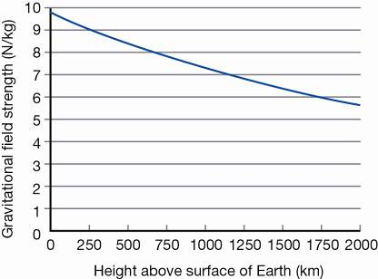  From this graph you can conclude that:  A The gravitational field strength of the Earth does not change as you travel further away from Earth.  B The gravitational field strength of the Earth increases as you travel further away from Earth.  C The gravitational field strength of the Earth decreases as you travel further away from Earth.  D The gravitational field strength of the Earth only extends to 2000 km above the Earth’s surface. | C | 1
 | If you were to stand on a pair of scales at a height of 1000 km above the surface of the Earth:  A the reading would be the same as it is on the Earth’s surface.  B the reading on the scales would be greater.  C the reading on the scales would be lower.  D there would be no reading on the scales. | C | 1

